Greartisan Motor Redesign

**Greartisan Motor Redesign**

Technical Report

Mechanical Design II: 2254 MEMS 1029 SEC 1040

Feb 9, 2025

*- Prepared by -*

Irving Zhang, Tyler Watson, Anna Liu, Aidan Sullivan

1. **Technical Summary**

Our team of consulting engineers, Group Three, has been tasked with redesigning the Greatisan JSX 950-370 worm and spur gear motor to enhance its speed and power while maintaining cost efficiency. This project requires a thorough technical analysis of the existing commercial motor to identify areas for improvement.

The supplied motor drives a worm gear, which meshes with a compound four-gear spur train to achieve significant speed reduction with an increase in torque. The enclosure contains two non-rotating axles acting as pivotal supports for the three intermediate gears. The largest spur gear determines the rotational speed of the final output shaft, which directly impacts the motor’s torque.

From our analysis, the motor operates with an input speed of 115.5 RPM and an output torque of 0.46 N-m, with a cumulative gear ratio of 10.5:1.

Our proposed design modifications include:

* **Adjusting teeth on gear 5** from 45 to 15 to achieve an output of 40 RPM at doubled power 1.06 W.
* **Optimizing the gear material selection** to improve safety factors and durability while maintaining cost-effectiveness.
* **Increasing gear face width** to reduce the bending stress.
* **Incorporate lubrication** to reduce any friction losses.
* **Enhancing the bearing support structure** to reduce friction losses more and improve efficiency.
* **Moving Shaft C** 7.5 mm closer to Shaft B to maintain meshing alignment.

These changes aim to double the motor’s power output, achieving an output speed of 40 RPM, and maintain reliability and manufacturability. The following sections provide a detailed breakdown of our analysis and proposed improvements.

1. **Detailed Design Characterization**

For measurements of each component of the system, view Tables 4-6 in the V. Summary section. Note our nomenclature for the rest of the report,

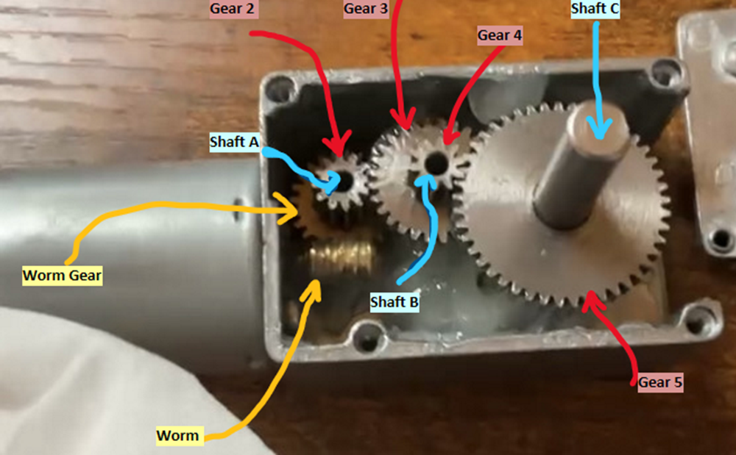

*Table 1 - Bill of Materials*

| Key Components | Estimated Cost |
| --- | --- |
| 1x Worm Gear | $2.50 |
| 1x N2 Gear | $1.00 |
| 1x N3 Gear | $1.50 |
| 1x N4 Gear | $1.00 |
| 1x N5 Gear | $2.25 |
| 1x Enclosure | $3.25 |
| 1x Shaft A | $0.50 |
| 1x Shaft B | $0.50 |
| 1x Shaft C | $1.25 |

1. **Technical Analysis**

To analyze each gear and shaft, use the force and moment equilibrium equations in each direction x-y, x-z, and z-y to form equations. These equations will allow us to solve for tangential forces on gears, shaft reaction forces, torques, and more.

*(all calculations are in the Python and Excel files)

Note some critical assumptions,

Current assumptions:

* Gears locked on the same shaft are rotating at the same speed.
* 100% efficiency on gears since friction would be small
* Pressure angle is 20 degrees
* Shafts A and B are aligned
* Shafts B and C are misaligned by an angle of 7 degrees
* Reasonable material picked for gears and shafts

Also, note the direction of rotation and our defined coordinate system,

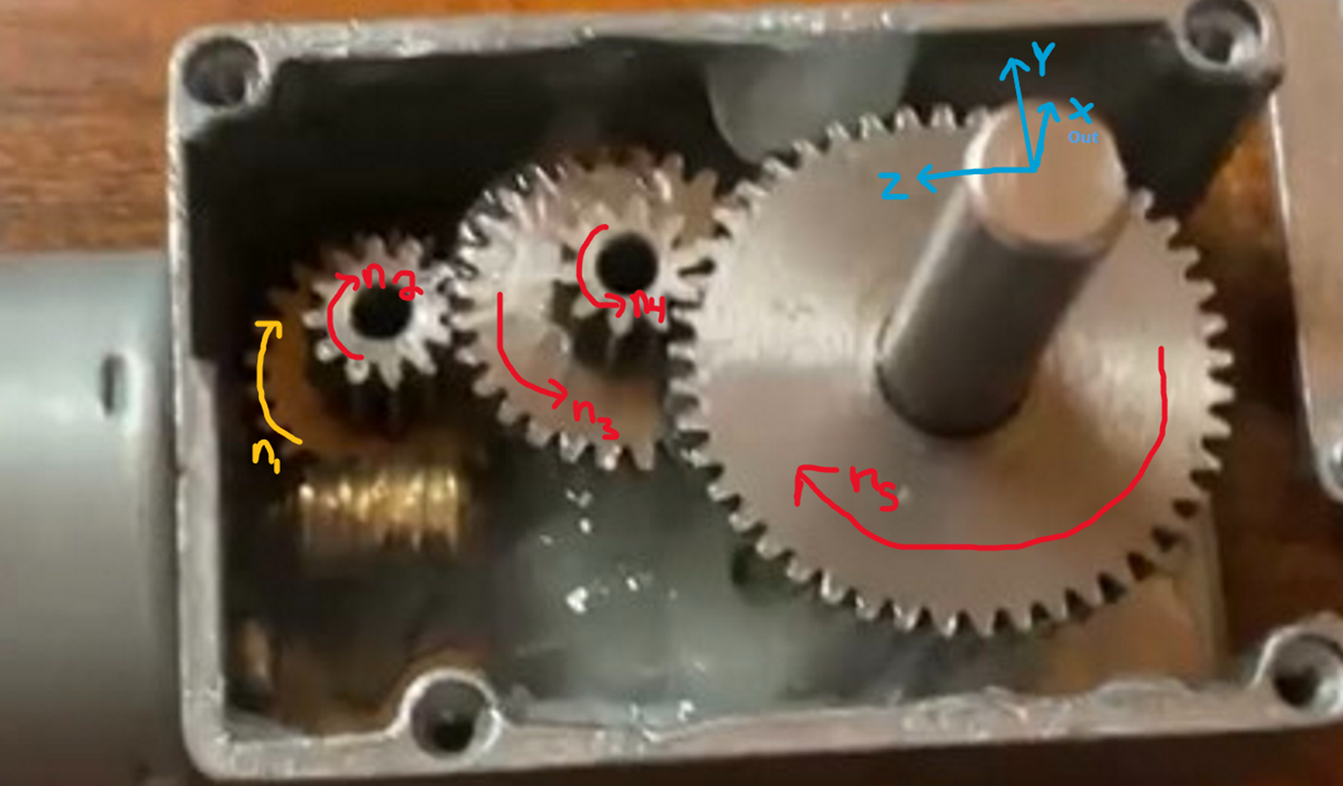

To begin our analysis, start from Shaft C as we know the output power *H.* The relation between torque, power and angular velocity is:

, so for

Then calculate Z-Y moment equilibrium in Shaft C:

-,

Then calculate Z-Y moment equilibrium in Shaft B:

(

Then calculate Z-Y moment equilibrium in Shaft A:

By knowing the gear ratio, we can calculate =/10.5, then we can get

Then calculate X-Y force and moment equilibrium in Shaft A:

We can get ,

Then calculate X-Y force and moment equilibrium in Shaft B:

,

Then calculate X-Y force and moment equilibrium in Shaft C:

,

Then calculate X-Z force and moment equilibrium in Shaft A:

,

Then calculate X-Z force and moment equilibrium in Shaft B:

,

Then calculate X-Z force and moment equilibrium in Shaft C:

,

With all forces on the shaft, now we can find the maximum shaft stress by plotting the shear and moment diagram. In this part, see Python code to calculate maximum momentum in shaft A, B and C.

, clockwise.

, counterclockwise.

, clockwise.

To find the maximum bending stress, we used this equation:

To find the maximum shear stress, we used this equation:

To find the torque shear stress, we used this equation:

where

All the stress results are in Table 4 in the V Summary section.

Stress in Gears

To begin the stress evaluation on each gear, we will use Lewis equation to find the maximum stress on a gear tooth.

, ,

We know that is dynamic factor, W is the face width, m is the modulus, is the tangential force component, Y is the Lewis form factor, V is the pitch line velocity.

For gear 2

8.62MPa

For gear 3

For gear 4

For gear 5

3.5826

1. **Redesign Description**

In this part, we will redesign our compound gear train for our motor, which has a transmitted power that is two times greater than the original and the desired output speed is 40 RPM. The input speed will still stay the same.

As we have the transmitted power doubled, the new power is

*Table 2 - Redesign in Gears*

| Gear # | Original teeth | Redesign teeth | Redesign  Gear Ratio | Original pitch diameter  [mm] | Redesign pitch diameter  [mm] |
| --- | --- | --- | --- | --- | --- |
| N5 | 45 | 15 | 3:1 | 22.5 | 7.5 |

After changing Gear 5, the new spur ratio will be:

The output velocity equals to:

，where

That means , to reach the need, we let =15

Other Changes in the Enclosure

Because we decrease the teeth of the Gear 5, to keep the same modules, the pitch diameter of the new gear will decrease

To keep working, Shaft C need to be moved closer to Shaft B by

*Table 3 - Redesign Cost*

| Gear # | Material | Cost | Change in Cost |
| --- | --- | --- | --- |
| Original N5 Gear  (45 teeth) | AISI 1018  Cold Drawn  Steel | $2.25 (if wholesale)  $3.75 (retail) |  |
| Redesign N5 Gear (15 teeth) | AISI 1018  Cold Drawn  Steel | $0.90 (if wholesale)  $2.40 (retail) | reduction |
| Redesign N5 Gear (15 teeth) | Carbon Steel | $0.32 | reduction |

Also, the cost of moving the shaft should be counted.

1. **Summary**

The analysis and redesign of the Greatisan JSX 950-370 worm and spur gear motor focused on reverse-engineering its components, evaluating performance under operational stresses, and modifying the system to accommodate doubled transmitted power and a higher output speed.

Below is a synthesis of key findings, measurements redesign outcomes, and design recommendations:

*Table 4 - Gear Summary*

| Gear # | Type | Teeth # | Outside Diameter  [mm] | Pitch Diameter  [mm] | Width  [mm] | Module [mm] | Material | Yield  Strength  [MPa] | Max  Stress  [MPa] | Factor  Of  Safety | Lewis Form Factor |
| --- | --- | --- | --- | --- | --- | --- | --- | --- | --- | --- | --- |
| w | Worm Gear | 24 | 5.5 | 12 | 3.79 | 0.5 | SAE 660  Bearing Bronze | 150 | - | - | - |
| n2 | Spur | 12 | 6.82 | 6 | 6.05 | 0.5 | AISI 1018  Cold Drawn  Steel | 370 | 8.62 | 42.91 | 0.245 |
| n3 | Spur | 28 | 14.68 | 14 | 2.59 | 0.5 | AISI 1018  Cold Drawn  Steel | 370 | 14 | 26.47 | 0.353 |
| n4 | Spur | 10 | 6 | 5 | 2.59 | 0.5 | AISI 1018  Cold Drawn  Steel | 370 | 2.78 | 133.24` | 0.23 |
| n5 | Spur | 45 | 22.97 | 22.5 | 0.58 | 0.5 | AISI 1018  Cold Drawn  Steel | 370 | 7.13 | 51.89 | 0.400 |

*Table 5 - Shaft Summary*

| Shaft | Length  [mm] | Diameter  [mm] | Material | Yield  Strength  [MPa] | RPM | Max  Bending  Stress  [MPa] | Max  Shear  Stress  [MPa] | Max Torque  [N-m] | Factor  Of  Safety |
| --- | --- | --- | --- | --- | --- | --- | --- | --- | --- |
| A | 20 | 2.45 | AISI 303  Stainless Steel | 240 | 0 | 178 | 1.4 | 4.83 | 1.35 |
| B | 19 | 2.45 | AISI 303  Stainless Steel | 240 | 0 | 591 | 12.4 | 2.07 | .406 |
| C | 33.01 | 6 | AISI 303  Stainless Steel | 240 | 11 | 30.8 | 1.85 | 0.46 | 7.79 |

*Table 6 - Gear Train Summary*

| Gear # | Cumulative  Gear Ratio | RPM | F_tangential  [N] | Assumed Efficiency  [%] |
| --- | --- | --- | --- | --- |
| n2 | 1:1 | 115.5 | 43.52 | 100 |
| n3 | 2.33:1 | 49.5 | 43.52 | 100 |
| n4 | 2.33:1 | 49.5 | 5.658 | 100 |
| n5 | 10.5:1 | 11 | 5.658 | 100 |

Redesign Outcomes

Gear Adjustments:

* Gear 5: Teeth reduced from 45 to 15 to achieve a new cumulative ratio of , enabling 40 RPM output at doubled power (1.06 W).
* Shaft C: Moved 7.5 mm closer to Shaft B to maintain meshing alignment.

Cost Implications:

* Gear 5:Material switched to carbon steel (85.7% cost reduction from original).
* Estimated savings: $1.93 per unit wholesale
* Total redesign cost: Minimal (only Gear 5 and shaft repositioning required).

Assumptions:

* Shaft stresses not recalculated; existing shaft designs retained.
* Commercial gear suppliers used for cost estimates.

Design Recommendations

Material Upgrades:

* Replace AISI 1018 steel gears with AISI 4140 alloy steel (yield strength: 655 MPa) to improve safety factors.
* Use hardened stainless steel (AISI 440C) for shafts to handle shear stresses.

Gear Geometry Optimization:

* Increase face width of gears to reduce bending stress.

System-Level Improvements:

* Incorporate lubrication to reduce friction losses (because assume 100% efficiency is overly optimistic).
* Add shaft supports/bearings to mitigate deflection in Shaft B.

Cost-Benefit Tradeoffs:

* Balance material upgrades with bulk purchasing to offset increased costs.

Conclusion

The original design prioritized cost efficiency over durability, resulting in critical stress points in Gear 3 and Shaft B. The redesign successfully increased output speed and power capacity through targeted gear adjustments while maintaining cost-effectiveness. Future iterations should focus on material upgrades and geometric optimizations to enhance reliability without significantly inflating costs.

1. **Work Breakdown**

Irving Zhang: Measured dimensions and key lengths for all components for tables and calculations, created the CAD models of the system, shear and moment diagrams in python along with max bending moment calculation

Tyler Watson: All FBDs, variables, python code/calculations for speeds, torques, gear forces, and shaft reaction forces, additional writing on technical summary, formatting of the report

Anna Liu: Technical Summary, Technical Analysis writing, Redesign, Bill of materials.

Aidan Sullivan: Stress analysis of gears and shafts

1. **Appendix**

# 1.FBD

## Gears

## Shaft A A diagram of a mathematical equation AI-generated content may be incorrect.A diagram of a triangle with red lines AI-generated content may be incorrect.A diagram of a circle with red lines and letters AI-generated content may be incorrect.A diagram of a circle with arrows and a circle with a circle AI-generated content may be incorrect.

## Shaft B

## Shaft C A diagram of a diagram AI-generated content may be incorrect.A diagram of a diagram AI-generated content may be incorrect. A diagram of a circle with a circle and a circle with a circle with a circle with a circle with a circle with a circle with a circle with a circle with a circle with a circle with AI-generated content may be incorrect.A diagram of a circle with arrows and a red circle with a red circle with a red circle with a red circle with a black line and a red circle with a red circle with a black line AI-generated content may be incorrect.

# 2.CAD Drawing

<https://github.com/IrvingNeon/ME>

# 3.Calculation Files

## Python File: [ME cal.ipynb](https://colab.research.google.com/drive/1hsoRak7NU8H5N0W9eurSZhE1MpA4w6yV?usp=sharing)

Excel File: [Stress Analysis.xlsx](https://pitt-my.sharepoint.com/:x:/r/personal/acs253_pitt_edu/Documents/Stress%20Analysis.xlsx?d=we01b91fcb46440478a017f82db59d45d&csf=1&web=1&e=7Cijnf)

## Gear speeds, torque, gear forces, reactions

## 

## 

## Maximum bending moment and shear+moment diagram:

### Shaft A:

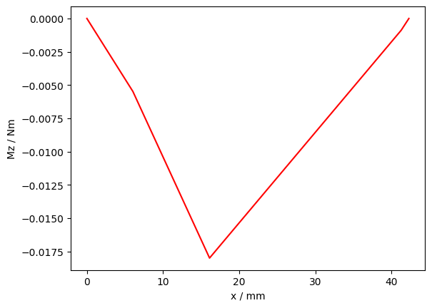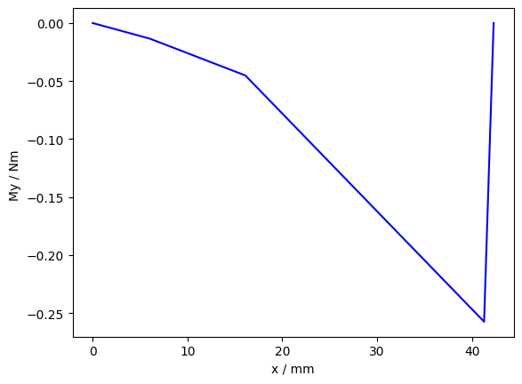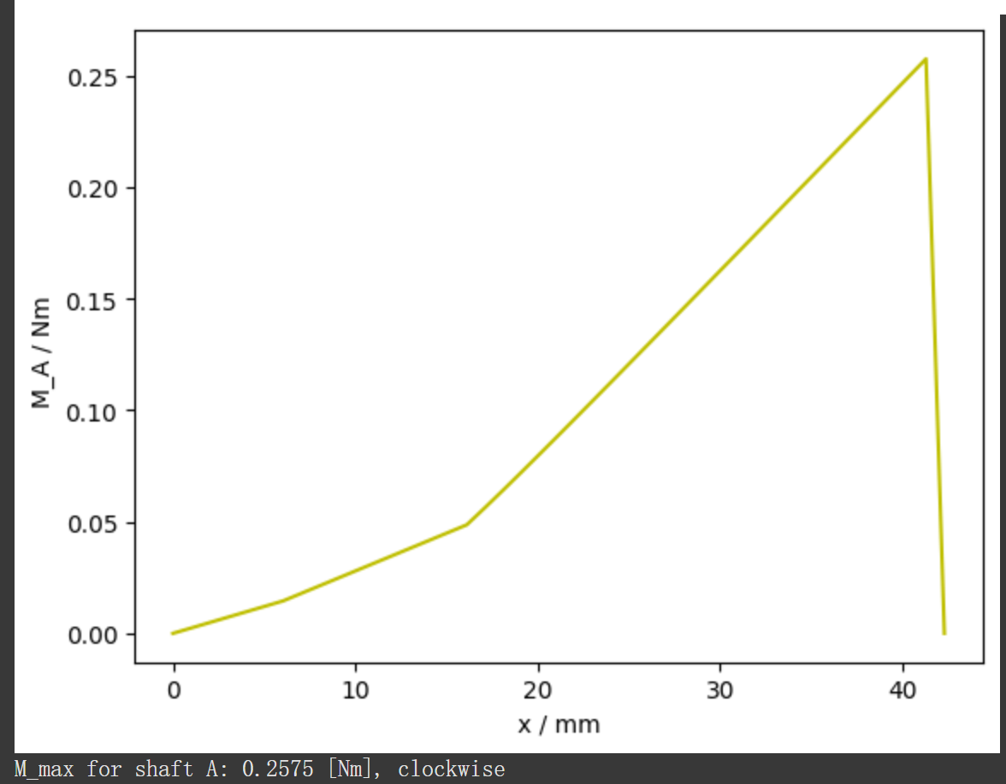

### 

### Shaft B:

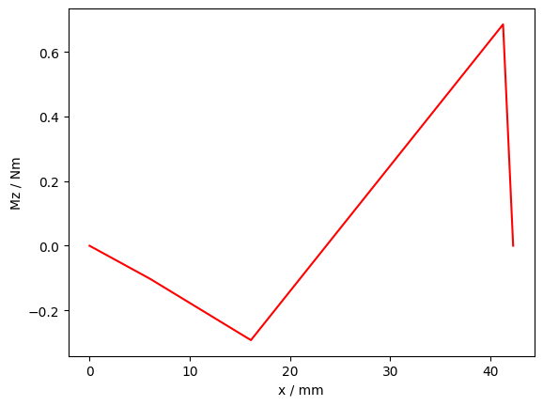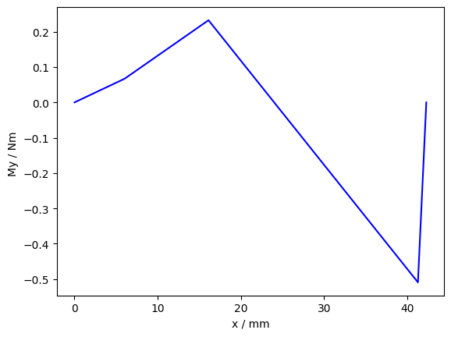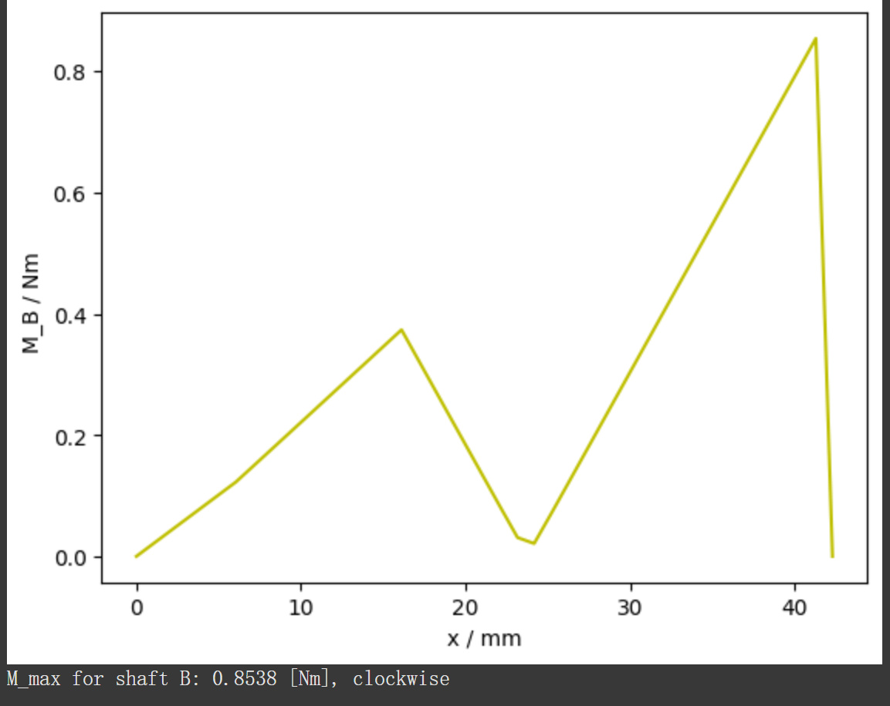

### Shaft C:

